

**WESTERFIELD COLLEGE**

**INTERNATIONAL FOUNDATION PROGRAMME**

**2023/2024 Academic Session**

**Mid Semester Exam**

**Candidate Name:**

**Candidate Number:**

**Information Technology (Paper 12) AS**

**Oct. 2023**

**1hr: 30min**

**INSTRUCTIONS**

* **Answer all question**
* **Use a black or blue pen. You may use an HB pencil for any diagrams or graphs.**
* **Write your name and candidate number in the boxes at the top of the page.**
* **Write your answer to each question in the answer booklet.**
* **Do not use an erasable pen or correction fluid.**
* **Do not write on the margin**
* **You may use calculator.**
* **You should show all your workings and appropriate units.**

**Question one**

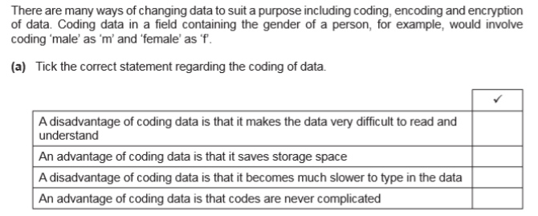

**Question Two**

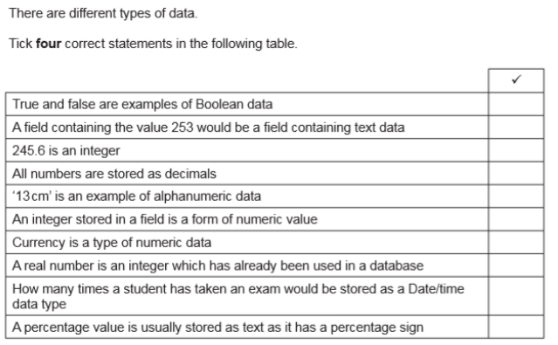

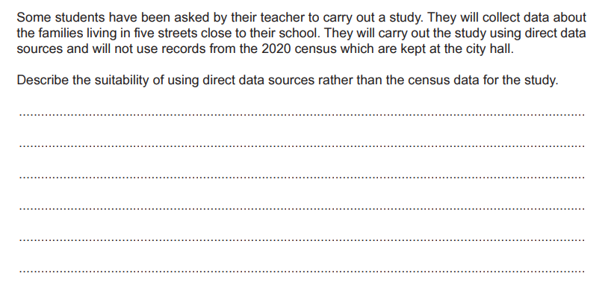**Question 3**

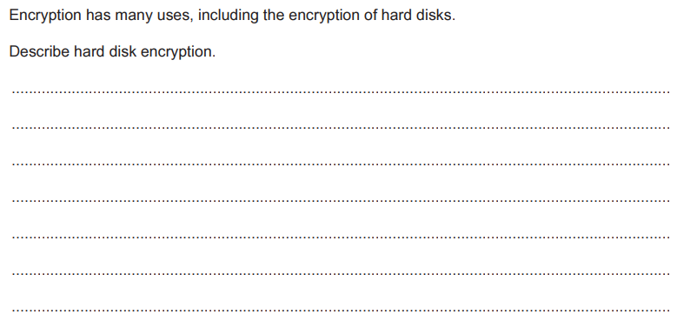**Question 4**

**Question 5**

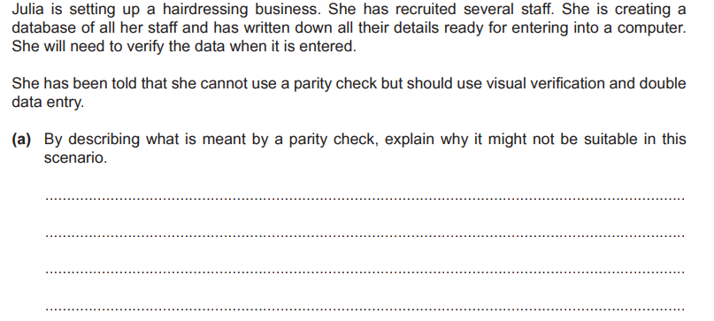

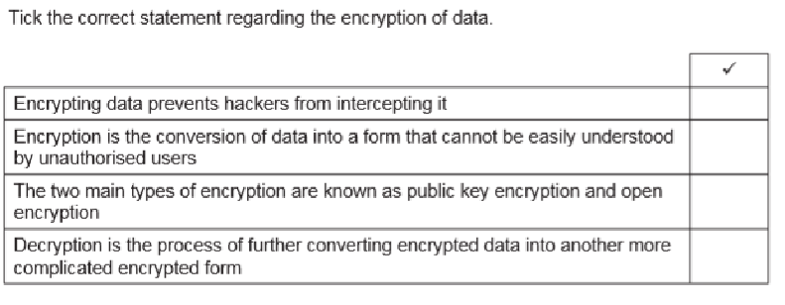**Question 6**

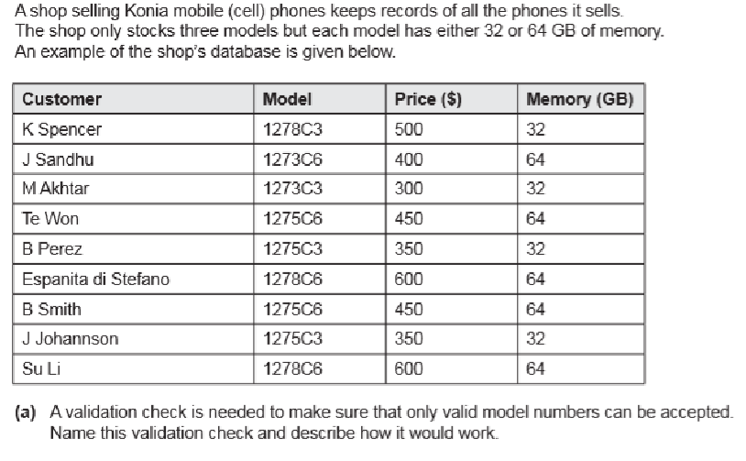**Question 7**

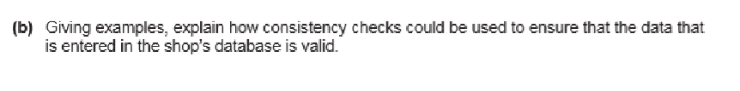

**Question 8**

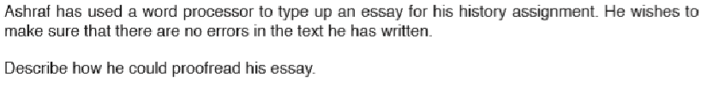**Question 9**

**Question 10**

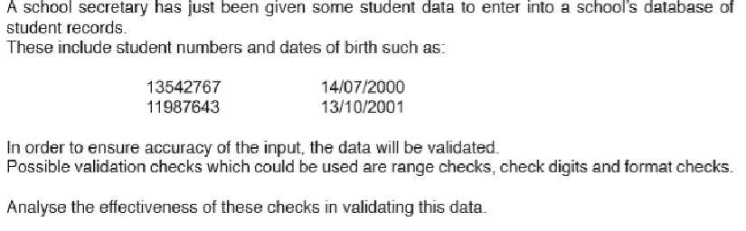

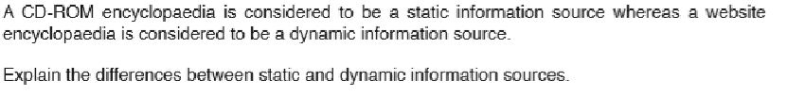**Question 11**

**Question 12**

